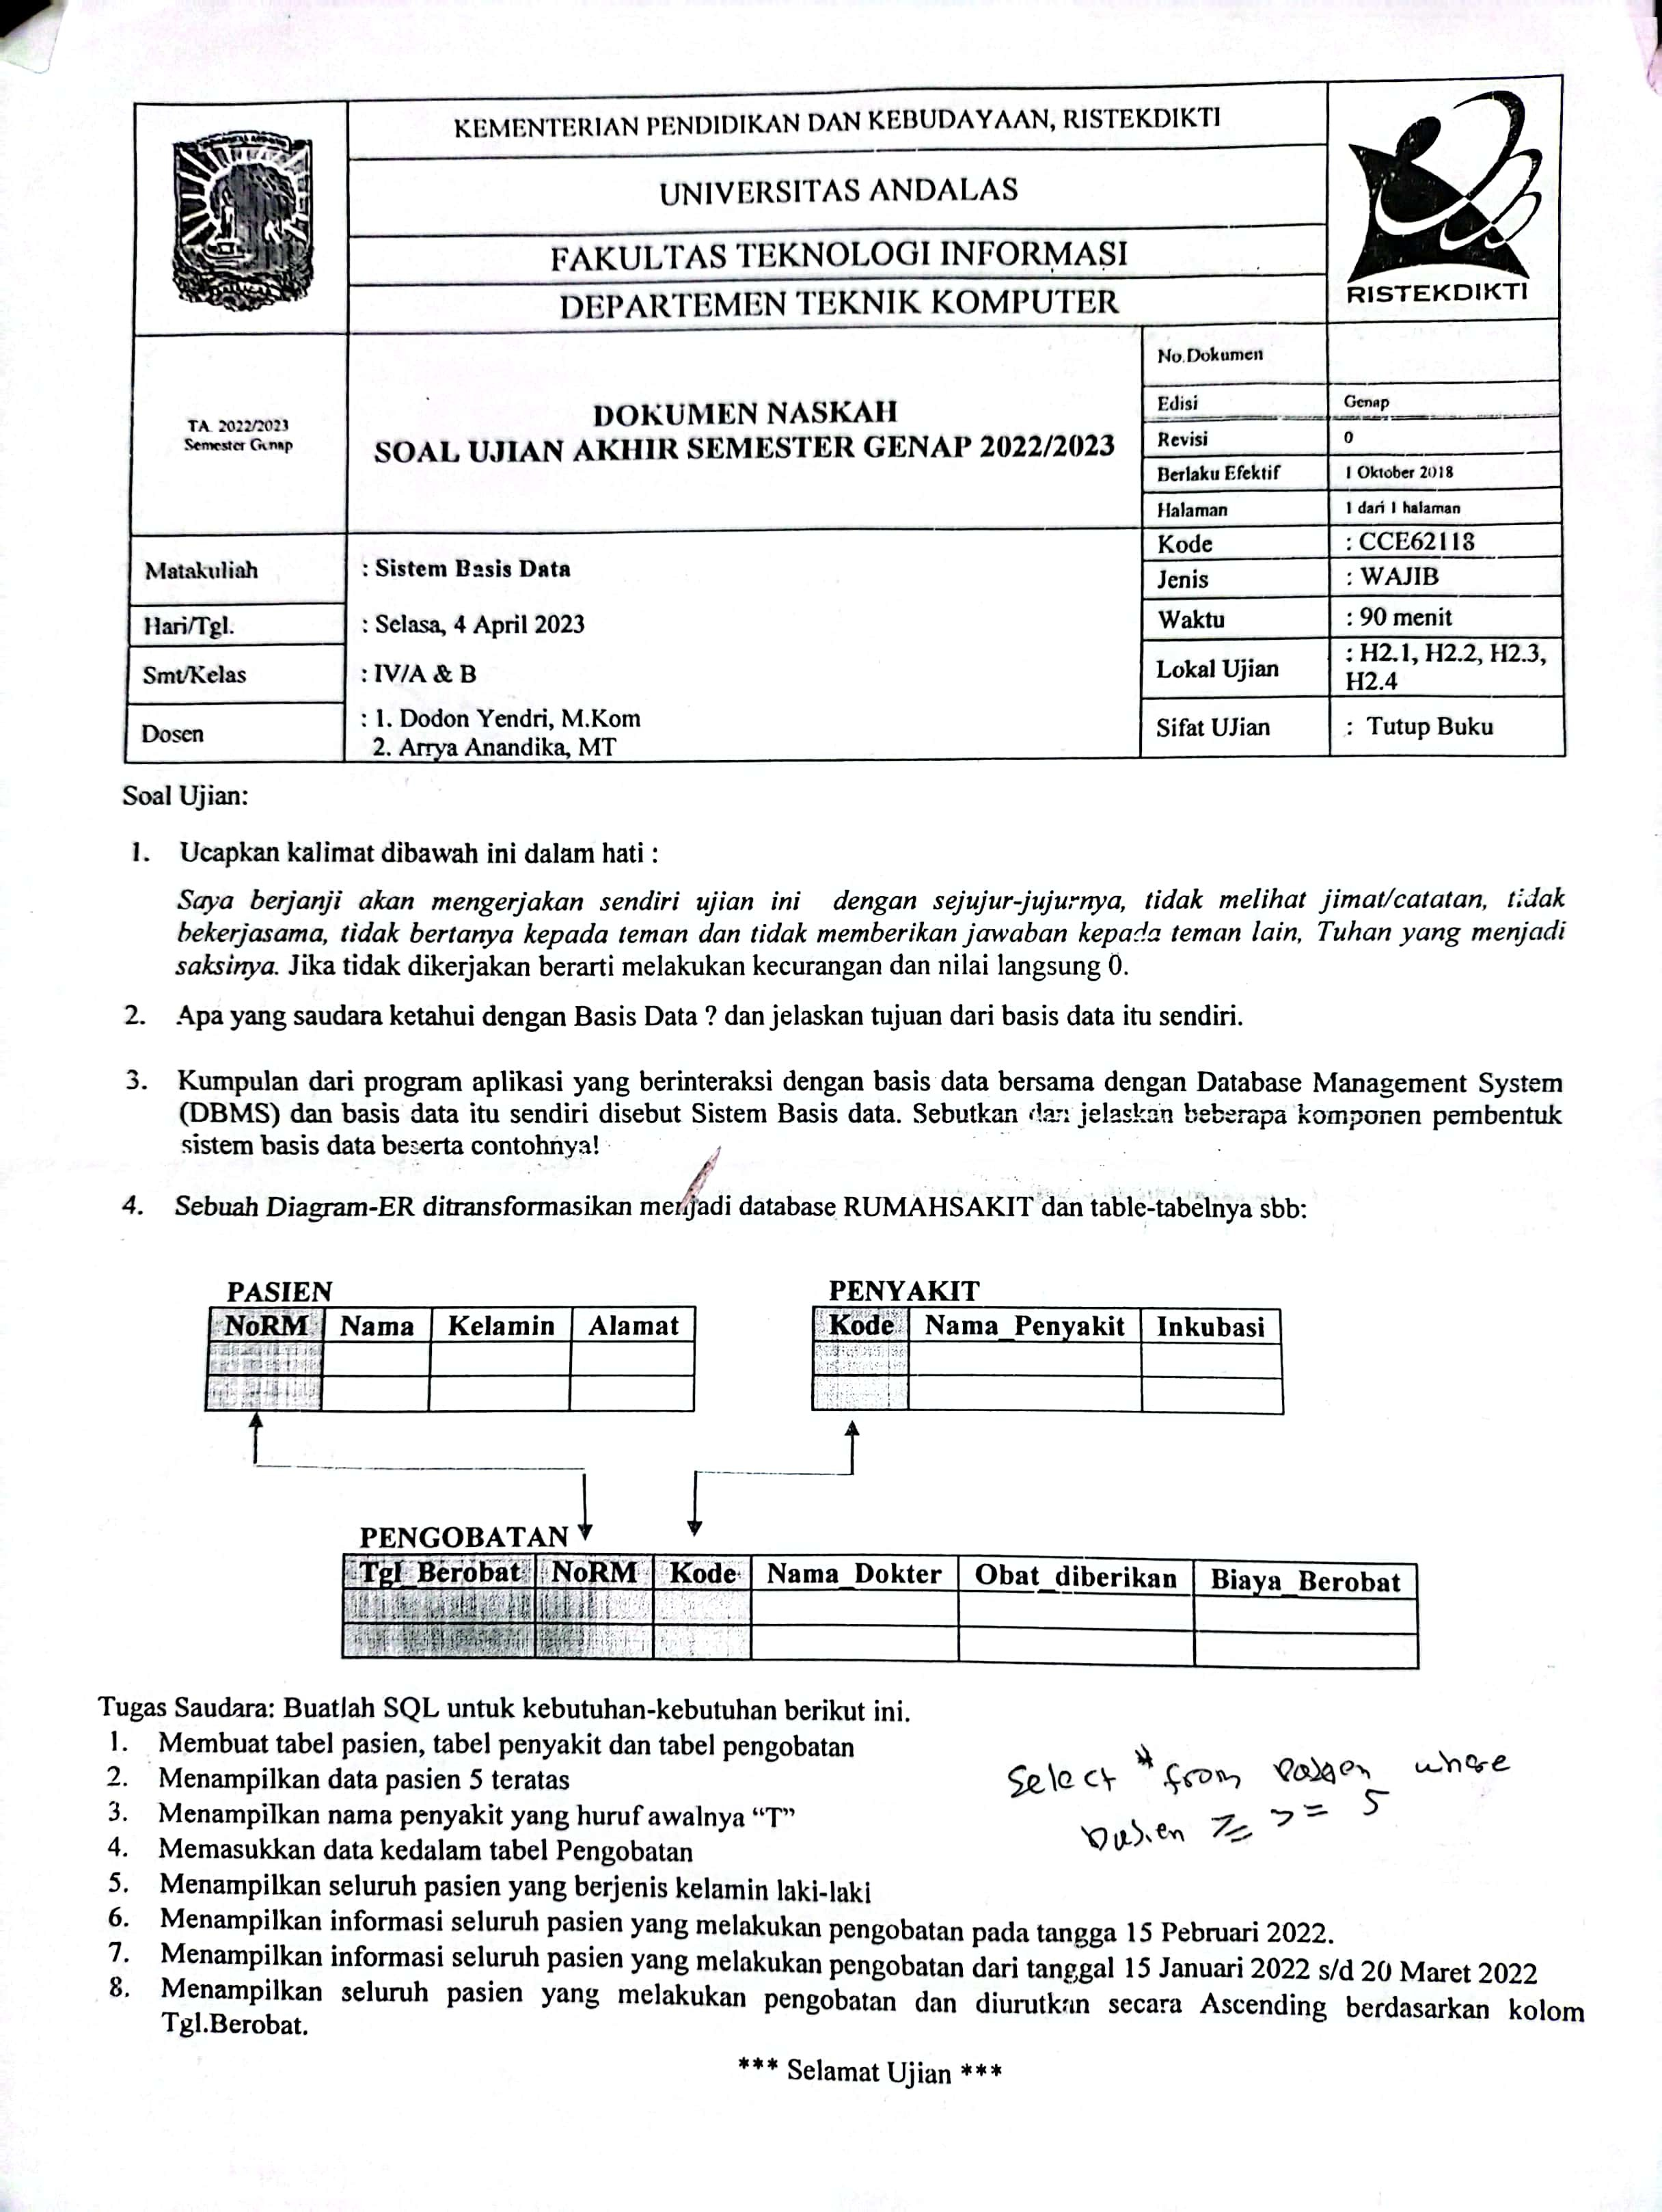

[](https://v3.camscanner.com/user/download)